Secure Application Programming
Project Template

Student Name: Kaitlin Moore
Student Number: x22477114
Module: Secure Application Development
Date: 05/12/2025q2

Revisions

Version | Primary Author | Description of Version | Date Completed
V1.0 | Kaitlin

Table of Contents

Table of Contents
Software Development Lifecycle Methodology 2
Introduction 2
Software Requirement Specification: 3
General Description: 3
Requirements : 3
Functional Requirements: 3
Non-Functional Requirements: 3
Data Classification: 4
Entity Relation Diagram (ERD): 4
Technical Specification: 5
High-Level Architectural Diagram 5
Wireframes: 5
Use-Case Diagram: 7
Use-Case Description: 8
Class Diagram: 12
Sequence Diagram: 12
Testing Plan 13
Discussion on the Insecure Code: 13
Discussion on the Secure Code: 13
Ethics Question: 13
Appendix A Breakdown of Marks 14
Appendix B 14

Software Development Lifecycle Methodology
Agile and Waterfall are two methodologies that don’t share many commonalities, but are both widely used throughout the software project lifecycle. I will explain the differences between Agile vs. Waterfall methodologies.

The Waterfall methodology:
The Waterfall methodology is a linear approach to software development. The name ‘Watermelon’ was chosen because of its progression that portrays a steady flow downward through clearly defined phases, like a waterfall. Each phase must be completed, documented, and reviewed before the project can progress and a new phase can begin. Once a new phase is completed, you cannot go back to the previous phase.

Core Phases:
- Requirements: All project requirements are gathered and documented from the beginning. This phase sets out to form a complete and detailed understanding of the final product.
- Design: The architecture of the system and its design specification, like the design of the interface, are created based on the final requirements.
- Implementation (code): The design specification is what the developer uses to develop the code.
- Verification: The completed product is tested against the original requirements formed at the start of the project to find defects. This usually happens at the end of the project.
- Maintenance: After the system is deployed, any ongoing maintenance, like changes, fixes, or updates, is handled.

Key Characteristics:
- Rigid Structure: The sequence is strict and predefined.
- Heavy Documentation: A large scale of documentation is created throughout each stage.
- Limited Customer Involvement: The user is very involved in the beginning phases and at the end.
- Predictable: Provides a clear guideline and easy progress measurement against the plan.

The Agile methodology:
Agile methodology is an iterative approach to software development that breaks an entire project into smaller, manageable cycles called iterations, also known as sprints in Scrum or a popular Agile framework. Each iteration aims to produce a working, functional piece of the software that can be demonstrated to the consumer.

Core Characteristics:
- Customer Collaboration: Ongoing collaboration with the consumer and stakeholders is a priority over rigid contract negotiation.
- Iterative and Incremental: Workload is delivered in small, functional increments, with each iteration building upon the last.
- Accepts Change: Agile is extremely adaptable, and changes are accepted even when they are far into the development process.
- Focus on Working Software: The primary measure of progress is working software, over extensive documentation.
- Time-boxed: Iterations are usually between 1-4 weeks long and include a full cycle of planning, development, testing and review.

Detailed Comparison: Waterfall vs. Agile:
FEATURE | WATERFALL | AGILE ITERATIVE MODEL
Approach | Sequential and linear (one phase must finish before the next begins). | Iterative and incremental (cycles repeat to build a product).
Requirements | It must be fixed and fully defined. Changes are difficult and expensive the more the project progresses. | Flexibility and changes are welcome throughout the project.
Customer Involvement | At the beginning and at the end. | Continuous involvement and feedback are provided after every iteration.
Risk Management | Risks are often identified late in the testing phase, which leads to high-cost fixes. | Risks are identified early and often, reducing stress.
Deliverables | A single, complete product is delivered at the end. | Small, working software increments are delivered every 2-4 weeks.
Testing | A separate phase that occurs at the end of the project. | Integrated throughout the development process in every iteration.
Documentation | Heavy emphasis on upfront documentation. | Focuses on necessary documentation and software.

Why would you choose Agile?
Agile Iterative Model would be used for the majority of modern software development projects, especially when:
- Requirements are unclear: When the end product is not completely defined in the beginning, this requires flexibility and is open to change. Agile allows the developer to gather feedback on an increment of working software and adjust the next iteration accordingly.
- Time-to-market is critical: A developer can deliver value to customers quickly. Agile provides frequent work releases that can generate revenue and gather real-world user data quickly.
- Active customer collaboration: The product owner or customer is willing to be heavily involved and provide regular feedback to guide the developer.
- Complexity is high: Stress on the project team is reduced because a complex project can be broken down into small, manageable iterations, which allows the team to focus and solve problems incrementally.

Why would you choose Waterfall?
Waterfall methodology would be used for projects with the opposite characteristics of the Agile Iterative Model.
- Requirements are fixed: The project scope is clearly defined, and there is a deep understanding that the requirements cannot and will not change.
- High predictability is required: A rigid schedule is needed with fixed cost estimates, and a clear sequential phase for regulatory or planning purposes.
- Sequential dependencies are strict: Under no circumstances can a new or later phase begin unless the preceding phase is finished.
- Limited customer access: If a customer is only available for the initial sign-off and final delivery, the documentation-heavy, front-loaded nature of Waterfall can be the only viable option.
In conclusion, for modern, target market-driven software where flexibility and quick feedback is necessary, Agile is the correct choice. For projects with rock-solid, non-negotiable and fully documented requirements, Waterfall provides a clear, highly structured path.

Introduction

I have built Secure-Notes, which is intended for people, mainly students, to use as a notes app to register, log in, create, read, search, edit and delete their notes. I have used Python as the language of choice for this application, SQLite for my database, FastAPI as my web framework and Jinja2 as my templating engine. I have two intentional versions of the Secure-Notes application. The first version is insecure, which has been built with flaws such as storing passwords in plaintext, lacking proper authentication and authorisation, being vulnerable to SQL injection and cross-site scripting (XSS), missing CSRF protection, and using insecure session handling. The second version is secure, which has been built with security measures such as bcrypt password hashing, secure session management, CSRF protection using server-generated tokens, XSS protection through Jinja2 autoescaping and a strict Content Security Policy, SQL injection prevention via SQLAlchemy ORM, input validation on user fields, and access control to ensure users can only manage their own notes. Together, these features make the application significantly more secure and resistant to common attacks. This report will showcase my progress, outlining the design, implementation and testing used throughout the development of both secure and insecure versions.

Software Requirement Specification:

General Description:
Secure-Notes is a simple web application that I have built to allow users, like students, to register, log in, create their notes or reminders or TO-DO lists, read them, search for them, edit them and delete them when they're finished. The insecure version Secure-Notes is set out to demonstrate the common vulnerabilities within websites, like SQL injection, XSS, poor session handling and sensitive data exposure, whereas the secure version shows proper protection measures for a website, like session management, secure headers, CSRF tokens and safe database operations. The goal for these applications is to highlight the importance of secure coding practices.

Principle of Least Privilege:
In Secure-Notes, when a user is logged in, they only have access to their own notes, and no other user can interact with their data. This ensures that each user operates with the minimum permissions required to use the application.

Principle of Secure Defaults:
The secure version I have created of Secure-Notes uses defensive defaults, like secure session cookies, safe password hashing, escaped templates and restrictive content security policies. These protections are automatically enabled, reducing the chance of misconfiguration.

Principle of Fail Securely:
Errors can happen like invalid logins, unauthorised note access and failed CSRF checks. The secure version of Secure-Notes handles these safely without revealing sensitive information. This blocks attackers from gathering insights into the system's behaviour.

Principle of Separation of Duties:
I developed Secure-Notes to separate responsibilities across different parts, like authentication, database operations, session management and request handling are all independently managed.
This means that if one component fails, this will not affect the rest of the system.

Principle of Defense in Depth:
The secure version of Secure-Notes applies multiple layers of protection, which include CSRF tokens, secure sessions, password hashing, input validation, strict CSP headers and SQL Alchemy OMR safeguards. These overlapping defense’s help ensure that if one defense fails, others remain in place to protect the application.

Requirements :
Define your web application. Describe what you are building. Set out the product scope by detailing what it can and cannot do.

Functional Requirements:
ID | REQUIREMENT
FR 1 | Secure-Notes should allow users to create an account through the registration page.
FR 2 | Secure-Notes should allow a user to log in using their valid credentials.
FR 3 | Secure-Notes should authenticate the user and allow access to their personal notes page.
FR 4 | An authenticated user should be able to create a new note.
FR 5 | An authenticated user should be able to view and read their own notes.
FR 6 | An authenticated user should be able to edit their notes.
FR 7 | An authenticated user should be able to delete their unnecessary notes.
FR 8 | An authenticated user should be able to search for their notes through the title of the note.
FR 9 | The user should be able to securely log out of Secure-Notes.

Non-Functional Requirements:

ID | REQUIREMENTS | SMART REQUIREMENTS
NFR 1 | Performance | The web application should load the main dashboard within 2 seconds under normal network conditions, which is measured by Chrome Lighthouse performance scoring above 80.
NFR 2 | Accessibility | Secure-Notes should meet basic accessibility standards that include proper semantic HTML, alt text and keyboard navigation, which achieves a Lighthouse accessibility score of 90.
NFR 3 | Security | The secure version of Secure-Notes should implement HTTPS, CSP, secure cookies, CSRF protection and input validation, which achieves a Lighthouse Best Practices score of 85 or higher.
NFR 4 | Usability | All user interactions through Secure-Notes, like registration, log in, creating notes, editing notes, searching notes and deleting notes, should be natural and require nothing more than 3 user actions to complete each task.
NFR 5 | Reliability | Secure-Notes should be able to handle concurrent use by at least 10 users without data loss or crashing. The application must maintain stable sessions throughout a 15-minute active session period.
NFR 6 | Search Engine Optimisation | Secure-Notes is not a public-facing website, but the secure version should follow technical SEO standards, which include metadata, clean URLs and mobile-friendly layouts, meeting a Lighthouse SEO score of 90 or above.
NFR 7 | Maintainability | The code should be organised into clear modules like authentication, notes CRUD and database access, with comments and documentation so that a new developer can understand core functionalities.
NFR 8 | Scalability | The system should be capable of migrating from SQLite to a production-grade database without major code restructuring and ensuring future scalability.

Data Classification:
Type Of Data | Basis for collection | Security features to protect  Insecure vs Secure
Username / Email (PII) | Account creation, login, and identifying users' ownership of notes. | Insecure: Minimal input validation, expansive login errors and data storing without protection.  Secure: Validated input, stored as unique fields, generic error messages, protected through access control and secure session handling.
Password (Sensitive Authentication Data) | User authentication and access control. | Insecure: Stored in plaintext, fully exposed if the database is compromised.  Secure: Hashed using bcrypt with salt and never stored in a reversible form.
Session ID / Token | Maintain authenticated sessions between requests. | Insecure: Authentication through URL parameters, no session management and tokens are exposed.  Secure: Proper server-side sessions, HTTPOnly, secure cookies, session regeneration and expiry timers.
Notes Content (User-Generated Data) | Core function of the application, creating, reading, searching, editing and deleting notes. | Insecure: No sanitisation, unescaped rendering and vulnerabilities to stored XSS.  Secure: Input validation, Jinja2 auto-escaping, CSP header, parameterised queries through ORM and user-specific access controls.
User ID / Note ID | Maintaining ownership by mapping notes to specific accounts. | Insecure: IDs are exposed in the URL, no authorisation checks, and it is vulnerable to ID tampering.  Secure: Server-side permission checks, ORM queries to prevent SQL injection and IDs are stored as controlled integers.
Log Entry Data | Monitoring user activity and detecting unusual behaviour. | Insecure: No logging or unsafe debug outputs result in revealing errors and information.  Secure: Dedicated logging with minimal PII, secure storage, rotation and restricted access for auditing.

In summary, to prevent sensitive data from running the risk of exposure in the secure version of Secure-Notes, several protections have been implemented. These protections include passwords being hashed using bcrypt, ensuring that even if the database is compromised, a user’s password cannot be retrieved in plain text. Session management uses HTTPOnly cookies, which prevent client-side scripts from accessing or stealing tokens. Input sanitation and output encoding safeguard user-created notes against XSS attacks, ensuring that harmful scripts cannot execute when the data is shown. Database operations that utilise ORM and strict access control safeguard against SQL injection and unauthorised access to the notes of other users. Together, these measures strengthen the confidentiality of user data compared to the insecure version.

Entity Relation Diagram (ERD):
ENTITY | ATTRIBUTE | DATA TYPE | DESCRIPTION | ROLE
USER | user_id | Integer | Unique identifier for a user | Primary Key
 | username | Text (unique) | Username used for login | Unique Index
 |  | Text | Password stored as salted and hashed value | Authentication
  hashed_password
 |  | DateTime | Timestamp of account creation | Metadata
  created_at
 |  | Text |  | Access control
  role
  User role (optional, e.g., admin or user)

ENTITY | ATTRIBUTE | DATA TYPE | DESCRIPTION | ROLE
NOTE | note_id | Integer | Unique identifier for the note | Primary Key
 | user_id | Integer | Links note to its owner (user) | Foreign Key
 | title | Text |  | Content
  Title of the note
 |  | Text |  | Content
  content
  Main body of the note
 |  | DateTime | Timestamp when note was created | Metadata
  created_at
 |  | DateTime | Timestamp of last update | Metadata
  updated_at

The relationship between these two entities supports Secure-Notes logic:

A user can create as many notes as they like, but each note belongs to only one user, which is the user who created the note. This is a one-to-many relationship which is enforced through the user_id foreign key in the Note table.

This relationship is the roots to implementing the Prrinciple of Least Privilege, ensuring that users can only access and manage their own notes.

All database queries must include a condition like WHERE user_id = ?. This is to enforce ownership checks and prevent unauthorised data access.

Technical Specification:
I have built SecureNotes using Python as my language with a FastAPI framework because it provides a fast, modern and efficient backend for handling user requests and data processing. SQLite is my database used for managing user and note data through SQLAlchemy ORM to ensure a secure and structured database relationship. For the frontend, I have used Jinja2 templating for dynamic HTML rendering, including strong security measures such as CSRF protection, session management and input validation. A user's password is securely hashed with bcrypt and the application enforces strict access controls to maintain user data privacy. These technologies make Secure-Notes a robust, scalable and secure notes application.

High-Level Architectural Diagram
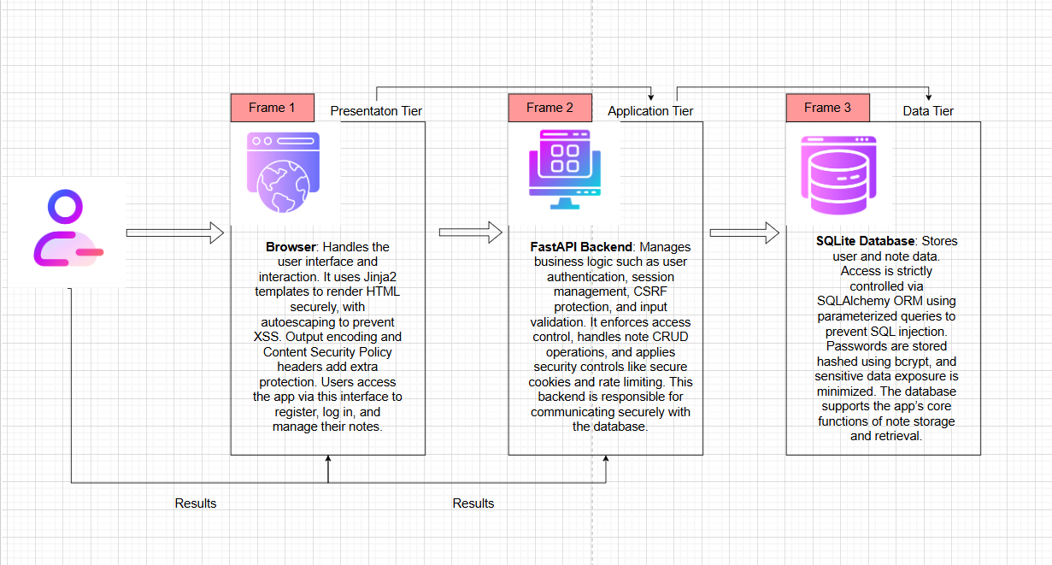

This diagram is a demonstration of the three-tier architecture for Secure-Notes to demonstrate the separation of duties. The first tier, the presentation tier, handles the user interface and interaction, rendering HTML securely and managing user access to the application. The second tier, the application tier, is the FastAPI Backend responsible for business logic like user authentication, session management, security measures and CRUD operations for notes, this carries out secure communication with the database. The third tier, the data tier, consists of an SQLite Database that stores user and note data, enforcing security through ORM queries, password hashing and minimising sensitive data exposure to support core application functionalities like note storage and retrieval of notes.

Wireframes:
Provide a wireframe of each page in your application this will help you when you come to fill out your Use-Case Description.



Page 1

Page 2

Page 3

Use-Case Diagram:
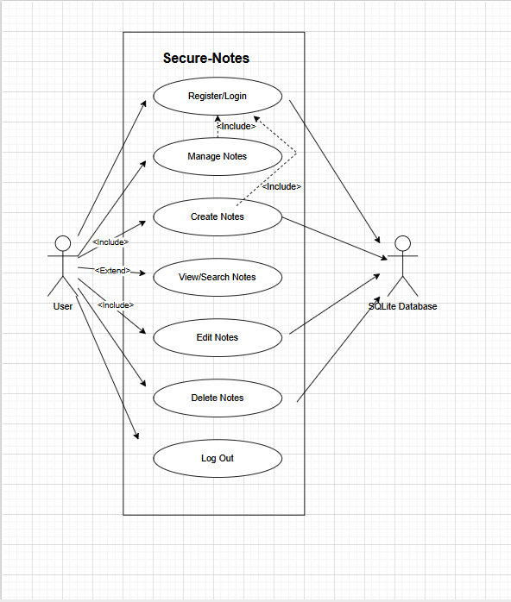
Use-case | Use-Case Name | Description
UC-1 | Register/Login User | Allows a new user to create an account and log in within the Secure-Notes system.
UC-2 | Manage Notes | Allows an authenticated user to create, view, search, edit and delete their own notes.
UC-3 | Create Notes | Allows an authenticated user to create and save a new note.
UC-4 | View/Search Notes | Allows an authenticated user to retrieve and view a list of all their existing notes.
UC-5 | Edit Notes | Allows an authenticated user to modify the content of an existing note.
UC-6 | Delete Notes | Allows an authenticated user to permanently remove an existing note.
Use-Case Description:
UC | UC-1
Use Case Name: | Register/Log in User
Created By: | Kaitlin Moore | Last Updated By:
Date Created | 1/12/2025 | Last Updated Date
Description: | Allows a new potential user to successfully create an account and log in to the Secure-Notes system by providing a username and password.
Actors:  Primary  Secondary | Primary - User
Triggers: | User navigates to the registration page and initiates the registration process.
Pre-conditions: | The User must not already have an account.
Post-Conditions: | The User's account details are successfully stored in the database. The user is redirected to the login page, where their username and password is needed again to verify and access the Secure-Notes main page.
Normal Flow: | 1. User accesses the registration page.  2. System prompts for username and password.  3. User enters required details and submits.  4. System validates input (e.g., checks if username exists, checks password complexity).  5. System hashes the password (secure version) and stores the new user record in the database.  6. System confirms successful registration.
Alternate Flows: | 4 (A). Input Validation Fails: System displays an error message for invalid input (e.g., blank field) and remains on the registration page.
Exceptions: | 5 (A). Database Error: An unexpected issue prevents the user record from being saved. The system displays a generic error message.
Includes:

Extends:

Priority: | High (Initial access to the system)
Special Conditions: | The secure version must enforce a minimum password complexity rule during submission.
Assumptions: | The system is operational, and the database is accessible. The username is unique.
Notes and Issues: | The insecure version stores the password in plaintext. The secure version uses bcrypt for irreversible password hashing.

Use Case ID: | UC – 3
Use Case Name: | Create Notes
Created By: | Kaitlin Moore | Last Updated By:
Date Created | 1/12/2025 | Last Updated Date
Description: | Allows an authenticated user to compose and save a new note or reminder to their account.
Actors:  Primary  Secondary | Primary – Authenticated user
Triggers: | An authenticated user clicks the "Create New Note" button/link.
Pre-conditions: | The User must be authenticated (Includes: Login).
Post-Conditions: | A new Note record, associated with the User's ID, is successfully stored in the database. The User is redirected to view the new note or their list of notes.
Normal Flow: | 1. User is authenticated (Login).  2. User accesses the 'Create Note' form.  3. System presents a form for note title and content.  4. User enters the note details and submits.  5. System performs input validation and sanitisation (XSS protection).  6. System saves the new note to the database under the User's ID (Access Control).  7. System displays a success confirmation.
Alternate Flows: | 4 (A). User doesn’t include title: User does not include a title for the note; the system will give an error and not create the note until a title is included.
Exceptions: | 5 (A). Validation Error: The note content fails validation (e.g., too long). The system displays an error and keeps the form data.
Includes: | Login
Extends:

Priority: | High (Core functionality)
Special Conditions: | The secure version must use a CSRF token to protect the form submission. Note content must pass input validation and be displayed with Jinja2 autoescaping.
Assumptions: | The User has sufficient space to create a new note.
Notes and Issues: | The insecure version is vulnerable to Cross-Site Scripting (XSS) and SQL Injection. The secure version prevents XSS via auto-escaping/CSP and SQL Injection using the SQL Alchemy ORM.

Use Case ID: | UC – 4
Use Case Name: | View/Search Notes
Created By: | Kaitlin Moore | Last Updated By:
Date Created | 1/12/2025 | Last Updated Date
Description: | Allows an authenticated user to retrieve and view a list of all their existing notes, including the ability to search them.
Actors:  Primary  Secondary | Primary – Authenticated User
Triggers: | Authenticated User navigates to the main notes dashboard/list page.
Pre-conditions: | The User must be authenticated (Includes: Login).
Post-Conditions: | A list of the User's notes is displayed, or the details of a specific, searched note are displayed.
Normal Flow: | 1. User is authenticated (Login).  2. User accesses the notes list page.  3. System queries the database for notes associated only with the User's ID (Access Control).  4. The system presents the list of notes.  5. User enters a search term.  6. System filters the notes based on the search term and displays results.
Alternate Flows: | 4 (A). No Notes Found: System queries the database but finds no notes. System displays a message: "You have no notes. Create one now."
Exceptions: | 3 (A). Database Connection Error: System cannot retrieve the notes. The system displays a temporary error message.
Includes: | Login
Extends: | Filter Notes by searching title.
Priority: | High (Core functionality)
Special Conditions: | Must retrieve notes using the User's ID to ensure Access Control and prevent unauthorized data viewing.
Assumptions: | The User has created at least one note.
Notes and Issues: | The insecure version lacks strong Access Control, potentially allowing a malicious user to view all notes in the database (Sensitive Data Exposure). The secure version strictly limits queries to the authenticated user's ID.

Use Case ID: | UC – 5
Use Case Name: | Edit Notes
Created By: | Kaitlin Moore | Last Updated By:
Date Created | 1/12/2025 | Last Updated Date
Description: | Allows an authenticated user to modify and save changes to an existing note that they own.
Actors:  Primary  Secondary | Primary - Authenticated User
Triggers: | An Authenticated User clicks the 'Edit' button next to an existing note.
Pre-conditions: | The User must be authenticated (Includes: Login).  The selected note must exist and belong to the User (Access Control).
Post-Conditions: | The selected note's details are successfully updated in the database.
Normal Flow: | 1. User is authenticated (Login).  2. User selects an existing note to edit.  3. System verifies ownership of the note (Access Control).  4. System populates an edit form with the current note details.  5. User makes changes to the title/content and submits.  6. System validates input, performs sanitisation, and updates the existing note record in the database.  7. System confirms successful update.
Alternate Flows: | 3 (A). Note Not Found/Not Owned: System cannot find the note, or the note belongs to another user.  System displays an error (e.g., "Note not found" or "Access Denied").
Exceptions: | 6 (A). CSRF Attack Blocked: The system detects a missing or invalid CSRF token. The update is rejected, and an error is logged.
Includes: | Login
Extends:

Priority: | High (Core functionality)
Special Conditions: | The edit request must be protected by a valid CSRF token. The system must verify the User owns the Note ID they are attempting to edit.
Assumptions: | The User has the necessary permissions (which they do, as the note belongs to them).
Notes and Issues: | The insecure version is highly vulnerable to CSRF and could allow an attacker to force a logged-in user to edit their notes. The secure version uses server-generated CSRF tokens and maintains strict Access Control.

Use Case ID: | UC – 6
Use Case Name: | Delete Notes
Created By: | Kaitlin Moore | Last Updated By:
Date Created | 1/12/2025 | Last Updated Date
Description: | Allows an authenticated user to permanently remove an existing note that they no longer need.
Actors:  Primary  Secondary | Primary – Authenticated User
Triggers: | An Authenticated User clicks the 'Delete' button next to an existing note.
Pre-conditions: | The User must be authenticated (Includes: Login).  The selected note must exist and belong to the User (Access Control).
Post-Conditions: | The selected note record is permanently removed from the database. The User is redirected to their updated list of notes.
Normal Flow: | 1. User is authenticated (Login).  2. User selects an existing note for deletion.  3. System presents a confirmation prompt (e.g., "Are you sure you want to delete this note?").  4. User confirms the deletion.  5. System verifies ownership and checks for a valid CSRF token.  6. System permanently deletes the note record from the database.  7. System confirms successful deletion and redirects to the notes list
Alternate Flows: | 4 (A). User Cancels: User clicks 'No' on the ‘Are You Sure’ prompt. System aborts deletion and returns the User to the notes list.
Exceptions: | 5 (A). Note Not Found/Not Owned: System cannot find the note, or the note belongs to another user. System displays an error (e.g., "Access Denied").  5 (B). CSRF Protection Failure: System detects a missing or invalid CSRF token. The request is rejected, and the action is logged.
Includes: | Login
Extends:

Priority: | Medium (Maintenance functionality)
Special Conditions: | The deletion request must be protected by a valid CSRF token to prevent forced actions. The system must verify the User owns the Note ID they are deleting.
Assumptions: | Deletion is permanent and non-recoverable.
Notes and Issues: | The insecure version is highly vulnerable to CSRF and lacks robust Access Control, potentially allowing an attacker to delete any note in the system by manipulating the Note ID. The secure version implements CSRF protection and strict Access Control (verifying note ownership before execution).

Class Diagram:

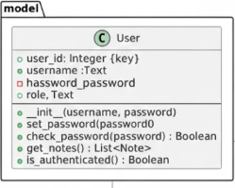

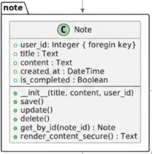

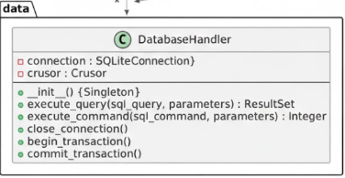

Design Principles/Patterns:

In Secure-Notes, I have applied the Singleton Pattern in areas where the application must rely on a single shared instance to keep up with security and consistency. By implementing this, it ensures that Secure-Notes only has one logging instance and one database connection throughout the application. This helps prevent issues such as multiple database connections happening at the same time. Using this pattern allows Secure-Notes to maintain consistent and secure for key components.

Layered Architecture:

Secure-Notes is separated into distinct layers: presentation, application and data. This separates the responsibilities so that the user interface and interaction, business logic and data storage all operate independently. If a change is made in one layer, this structure ensures that there is minimal impact on the other layers.

Solid Principles:

The Single Responsibility Principle is carried out by ensuring that each component has a focused purpose. User-related data and business logic are dealt with separately from database operations and request handling. The Open/Closed Principles are maintained, enabling the system to be extended without altering current components, which facilitates simple upgrades or modifications like changing database engines.

Dry Principle:

Centralising common functions such as password hashing and verification reduces redundancy, allowing these operations to be implemented only once and utilised across the system. Likewise, all database interactions route through a unified, central point, avoiding repeated connection management and fostering cleaner, more maintainable code

Sequence Diagram:

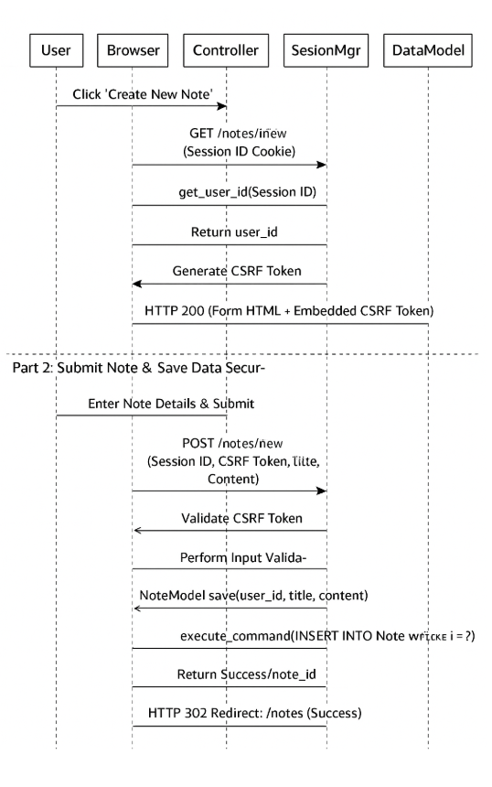

Load form with CSRF Token:
User -> Browser:
The user clicks the ‘Create New Note’ button, initiating the process to create a new note.
Browser -> Controller:
The browser sends a GET request to /notes/new with the session ID cookie included to identify the user session.
Controller -. Session Manager:
The controller asks the session manager for the user ID by providing the session ID from the cookie. This is an authentication check to confirm the user is logged in.
Session Manager -> Controller:
The session manager returns the user ID to the controller, confirming the user's authenticated session.
Controller -> Controller:
The controller generates a CSRF token to protect the form against Cross-Site Request Forgery attacks.
Controller -> Browser:
The controller responds with HTTP 200 OK, sending back the HTML form, which includes the embedded CSRF token for protection.
Submit Notes and Save Data Securely:
User -> Browser:
The user fills out the note details (title and content) and submits the form.
Browser -> Controller:
The browser sends a POST request to /notes/new, including the session ID cookie, the CSRF token, and the note data (title and content).
Controller -> Controller:
The controller validates the CSRF token to ensure the request is legitimate and not a forgery.
Controller -> Session Manager:
The controller requests the user ID again from the session manager using the session ID, to double-check authentication and identify the note owner.
Session Manager -> Controller:
The session manager returns the user ID.

Controller -> Controller
The controller performs input validation on the note data (checking for XSS, length) to ensure it is safe and valid.
Controller -> Note Model:
The validated data (user ID, title, content) is passed to the note model to save the new note.
Note Model -> Database Handler:
The note model sends an SQL insert command to the database to store the note securely, using parameterised queries (to avoid SQL injection).
Database Handler -> Note Model:
The database confirms the success of the insert operation and returns the newly created note.
Note Model -> Controller:
The note model notifies the controller that the save operation was successful.
Controller -> Browser:
The controller responds with an HTTP 302 redirect to /notes to display the updated list of notes, indicating the successful creation of the new note.

Testing Plan
Create a testing plan is based on the normal, Alternate and Exceptional flows in each Use Case Description.

Provide details of the results of this plan.

Use Selenium or Playwright to create tests of your application.

Test the Non-Function requirements of your App using the Chrome developer tools.

Carry out DAST testing on both the Secure and Insecure Branches of your Code using ZAP.
Highlight any Vulnerabilities raised by the tool.

Discussion on the Insecure Code:

When developing Secure-Notes, I deliberately implemented three critical web vulnerabilities to the insecure version to demonstrate the security risks outlined in the OWASP Top 10 (2021). These vulnerabilities include SQL Injection, Cross-Site Scripting (XSS) and Sensitive Data Exposure. This comparison between Secure-Notes Secure and Secure-Notes Insecure helped me understand how attackers can exploit these weaknesses in a real-world application.

SQL Injection:

In the insecure version of Secure-Notes, I used raw user inputs directly in database queries without proper sanitisation or parameter binding. In my ‘crud.py’ page, I added a function called ‘insecure_authenticate_user’ which filters users based on username and password.
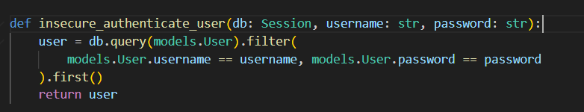

Even though SQL Alchemy’s ORM generally safeguards against SQL injection by internally parameterising queries, the absence of input validation and the method of transmitting the username (such as in URLs without encoding) increases the risk of manipulating query logic through specially designed inputs.

The insecure version of Secure-Notes does not implement prepared statements or proper input sanitisation, making it vulnerable to injection if raw SQL or insecure query construction were employed.

This vulnerability falls under ‘OWASP A03:2021 – Injection’, which highlights injection flaws that occur when untrusted data is sent to an interpreter as part of a command or query. The attack allows the execution of unintended commands or the access of unauthorised data.

Why is it Dangerous and Exploitation:

An attacker can submit malicious input such as ‘username: admin’. This input could manipulate the query to always equal true, which bypasses authentication controls and allows unauthorised access to all user accounts and data.

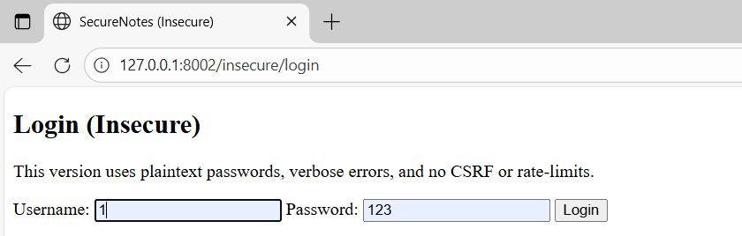

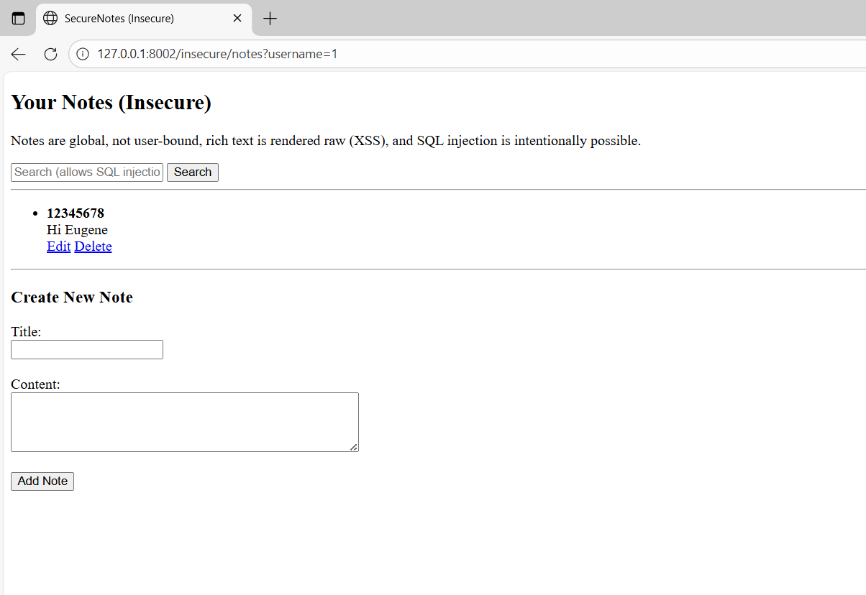

Cross-Site Scripting (XSS):

In Secure-Notes Insecure Your Notes Feature, I developed the application so that it accepts user inputs for a note title and content, but it does not sanitise or escape HTML special characters before displaying them again in the output.

In ‘notes.html’, the application I developed to allow users to create notes, the notes content is rendered using the Jinja2 template with the ‘| safe filter’.
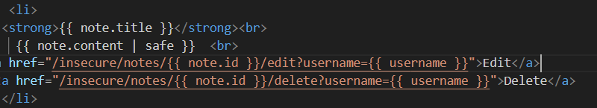

This disables Jinja2’s built-in auto escaping, resulting in any HTML or JavaScript entered by the user in their note being accepted and outputted without any sanitisation. Due to this, if a user inputs malicious comments or JavaScript code, it will be executed by the insecure version of Secure-Notes for all of their users to view.

This vulnerability is an example of ‘OWASP A07:2021 – Identification and Authentication Failures’ and XSS, where unsanitised user input leads to client-side script execution in other users' browsers.
Why is it Dangerous and Exploitation:

By injecting JavaScript, attackers can steal session cookies or tokens, resulting in other users' sessions being hijacked. Redirect users to malicious and unwanted websites and perform actions on behalf of innocent users.
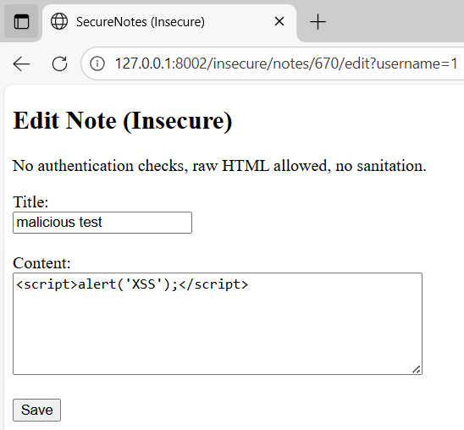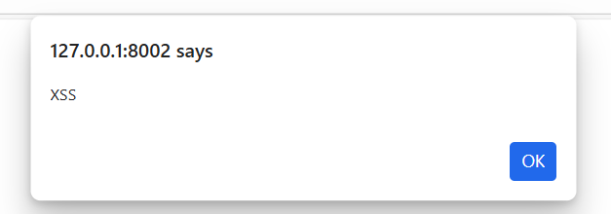

Sensitive Data Exposure:

Sensitive Data Exposure happens when an application fails to successfully protect critical information such as users' passwords, personal data or session tokens. In the insecure version of Secure-Notes, passwords are stored in plaintext in the database without any hashing or encryption.

In my ‘crud.py’ page, I have created an ‘insecure_create_user’ function which allows the application to directly save a user's password.
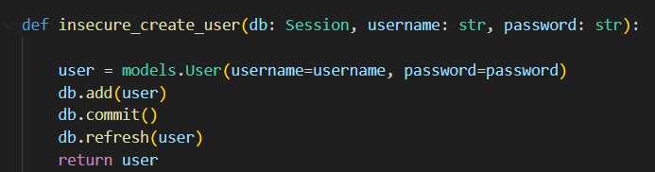

By implementing this, Secure-Notes does not follow cryptographic best practices for password storage, and this leaves sensitive data exposed.

This vulnerability is demonstrated in ‘OWASP A02:2021 – Cryptographic Failures, which talks about systems failing to apply proper encryption and protections to sensitive data like passwords.

Why is it Dangerous and Exploitation:

Due to passwords being stored in plaintext, an attacker who gains access to the database through SQL Injection, stolen backups, server misconfiguration or direct access can result in an attacker having immediate view to all user passwords without any effort.
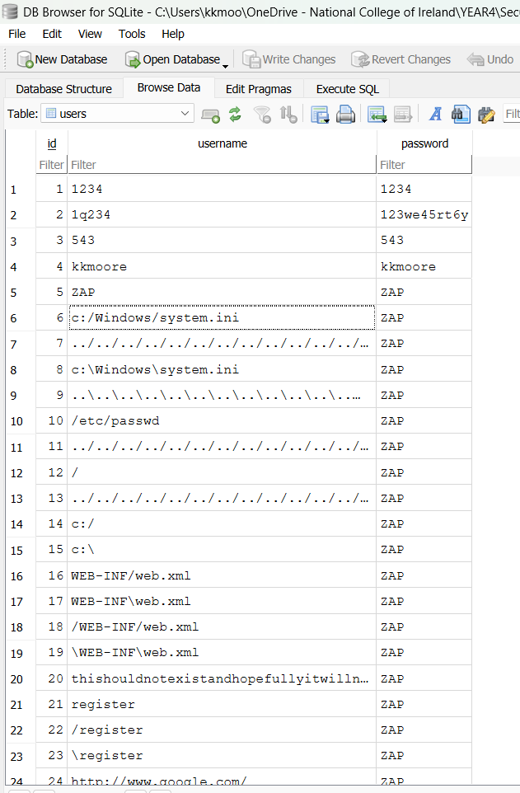

Discussion on the Secure Code:

When developing Secure-Notes Secure, I used this version to correct the vulnerabilities that I implemented in the insecure version, such as SQL Injection, Cross-Site Scripting (XSS) and Sensitive Data Exposure, and I did all of this by applying best practices recommended by OWASP.
Preventing SQL Injection:
To prevent SQL injection, I used SQL Alchemy ORM to carry out all the database operations. This results in user inputs such as usernames and notes that are never directly placed into SQL queries. Instead, SQL Alchemy handles the inputs safely by parameterised queries, which separate data from commands.

In my ‘crud.py’ page, I have developed a function called ‘get_user_by_username’, which is called in my authentication process to retrieve the user's record securely and protects the database from malicious inputs trying to change the query logic.
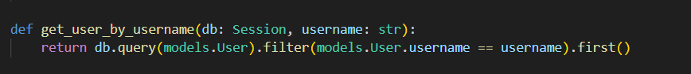

I also added input validation on the frontend using HTML form attributes like ‘pattern’ and ‘maxlength’, to limit what users can submit, reducing the chance of invalid or harmful input.
These techniques follow ‘OWASP - A03:2021 Injection’, which strongly recommends using parameterised queries and validating input.

Preventing Cross-Site Scripting (XSS):
To prevent XSS attacks, I have developed the secure version of Secure-Notes so that it escapes all user input before displaying it. A user's data is shown using Jinja2’s |e filter, which converts HTML special characters to safe text.

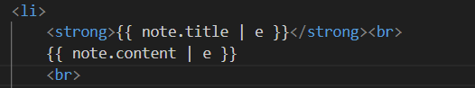

This ensures that any HTML or JavaScript entered by a user is shown as text, not executed by the browser.
When developing, I also included client-side input restrictions and did not use the | safe command to disable auto escaping as I did in the insecure version.

Ethics Question:
You are working as a contractor in a large software development company you like the work and the organisation and any future work will depend on how you get on with the lead developer. During the final stage of the project, you are tasked with alpha testing and performing a code review where you discover a major vulnerability that would seriously affect the confidentiality integrity and availability of sensitive data held by the organisation. This discovery was only possible because of a penetration test that you had performed for a different client but as part of that test, you signed a letter of engagement which included a non-disclosure clause. You advised the lead developer of your findings and because of a lack of time to fix that problem, he does not want to do anything about it.
Consider three of the Software Engineering Code of Ethics principles and describe what you are going to do about the ethical issues raised by this scenario.

Answer

Appendix A Breakdown of Marks
Section | Description | % mark
1 | Software Development Lifecycle justification | 10%
2 | Software Requirement Specification | 20%
3 | The Use of GitHub for code and project planning | 5%
4 | Discussion of Insecure code implementation | 20%
5 | Discussion of Secure code implementation | 20%
6 | Testing Documentation and results | 10%
7 | Short video demonstrating your project | 5%
8 | Ethics | 10%

Appendix B
Link to GitHub:

Link to Video Demonstration:

